**CHAPTER 1**

**INTRODUCTION**

* 1. **GENERAL**

The school is under SNDP trust. It is located at Karamveli, Pathanamthitta. The total plot area is 1.74 acres. The current plot includes a higher secondary block, computer lab, auditorium, high school block, mess, stage & guru mandiram. The major works are design of new HS block, renovation of auditorium, plan for basket ball, volley ball and shuttle court and other facilities.

The current HS block is about 70 years old hence this block should be demolished and a new building should be constructed. We are designing a G+1 building including 9 class rooms one office room, staff room and a lab. The auditorium block should be made acoustic and the some maintenance works should be done to make it more usable.

* 1. **OBJECTIVES**
* To analyse and design a G+1 school building
* To prepare a master plan for the school.
* To compare the results with STAAD.Pro
* To prepare a detailed estimate.

**1.3 SCOPE**

* Study of various elements of building.
* Modeling and design of the building in STAAD.
* Analysis and design of various structural components of the model building.
* Detailing of columns, beams, slabs with section proportioning and reinforcement.

**1.4 STATEMENT OF PROJECT**

1. Utility of building : Institutional building
2. No of stories : G+1
3. No of staircases : 1
4. Type of construction : R.C.C framed structure
5. Types of walls : Brick wall
6. Geometric details:

6.1Floor to floor height : 3.5m.

1. Materials:

7.1 Concrete grade : M20, M25

7.2 All steel grades: Fe415 grade

**1.5 DESIGN OF MULTI STORIED BUILDING:**

**1.5.1 General**

A structure can be defined as a body which can resist the applied loads without appreciable deformations.

Civil engineering structures are created to serve some specific functions like human habitation, transportation, bridges, storage etc. in a safe and economical way. Structural engineering is concerned with the planning, designing and the construction of structures.

Structure analysis involves the determination of the forces and displacements of the structures or components of a structure. Design process involves the selection and detailing of the components that make up the structural system.

The main object of reinforced concrete design is to achieve a structure that will result in a safe economical solution.

The objective of the design is

1. Column design
2. Beam design
3. Slab design

These all are designed under limit state method

**1.5.2 Limit state method:**

The object of design based on the limit state concept is to achieve an acceptability that a structure will not become unserviceable in its life time for the use for which it is intended. i.e it will not reach a limit state.

In this limit state method all relevant states must be considered in design to ensure a degree of safety and serviceability.

**1.6 SOFTWARES**

**1.6.1 GENERAL**

This project is mostly based on software and it is essential to know the details about these software’s.

List of software’s used

1. Bentley Staad pro(v8i)
2. Autodesk Auto cad
3. Autodesk Revit 2015



**1.6.2 STAAD**

Staad is powerful design software licensed by Bentley. Staad stands for structural analysis and design. Any object which is stable under a given loading can be considered as structure. So first find the outline of the structure, where as analysis is the estimation of what are the type of loads that acts on the beam and calculation of shear force and bending moment comes under analysis stage. Design phase is designing the type of materials and its dimensions to resist the load, this we do after the analysis. To calculate S.F.D and B.M.D of a complex loading beam it takes about an hour. So when it comes into the building with several members it will take a week. Staad pro is a very powerful tool which does this job in just an hour’s staad is a best alternative for high rise buildings. Now a days most of the high rise buildings are designed by staad which makes a compulsion for a civil engineer to know about this software. These software can be used to carry rcc ,steel, bridge , truss etc according to various country codes.

**Staad Editor:**

Staad has very great advantage to other software’s i.e., staad editor. staad editor is the programming. For the structure we created and loads we taken all details are presented in programming format in staad editor. This program can be used to analyze another structures also by just making some modifications, but this require some programming skills. So load cases created for a structure can be used for another structure using staad editor.

**Limitations of Staad pro:**

1. Huge output data

2. Even analysis of a small beam creates large output

3. Unable to show plinth beams.

**1.6.3 AutoCAD:**

AutoCAD is powerful software licensed by auto desk. The word auto came from auto desk company and cad stands for computer aided design. AutoCAD is used for drawing different layouts, details, plans, elevations, sections and different sections can be shown in auto cad. It is very useful software for civil, mechanical and also electrical engineer. The importance of this software makes every engineer a compulsion to learn this software’s. We used AutoCAD for drawing the plan, elevation of a residential building. We also used AutoCAD to show the reinforcement details and design details of a stair case. AutoCAD is a very easy software to learn and much user friendly for anyone to handle and can be learn quickly. Learning of certain commands is required to draw in AutoCAD.

**1.6.4 REVIT 2015**

Autodesk Revit is a building information modelling software for architects, landscape architects, structural engineers, MEP engineers, designers and contractors developed by Autodesk. It allows user to design a building and structure and its components in 3D, annotate the model with 2D drafting elements, and access building information from the building model’s database. Revit is 4D BIM capable with tools to plan and track various stages in the building’s lifecycle, from concept to construction and later maintenance and/or demolition.

CHAPTER 2

PLAN AND ELEVATION

* 1. **SITE PLAN**

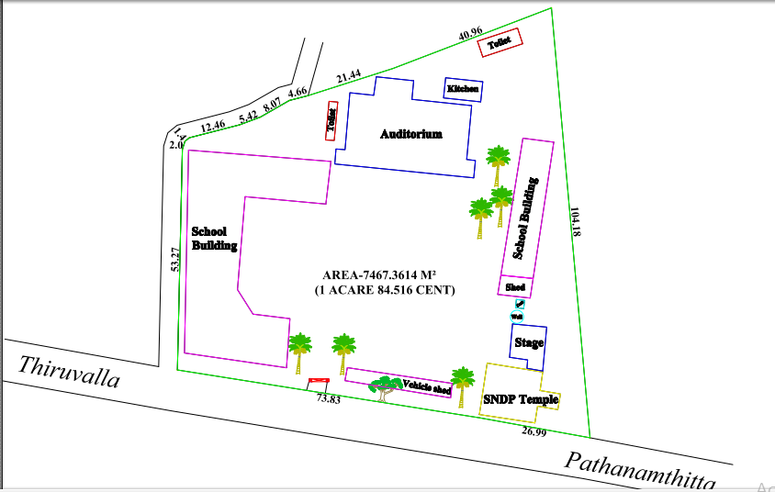

Fig 2.1 Site Plan (Plotted using total station)

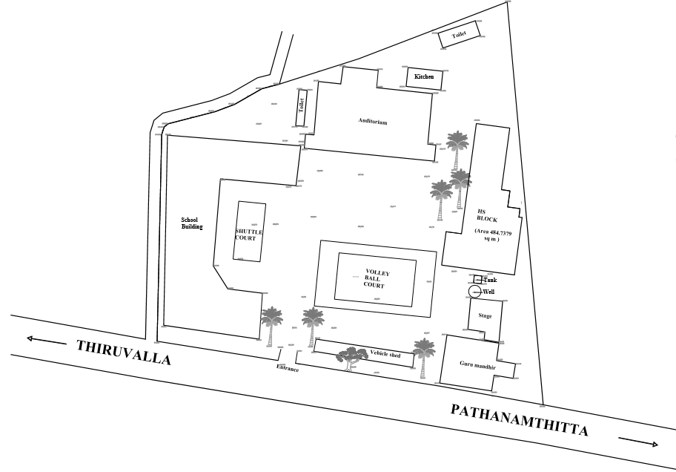

Fig 2.2 Proposed master plan

* 1. **GROUND FLOOR PLAN**

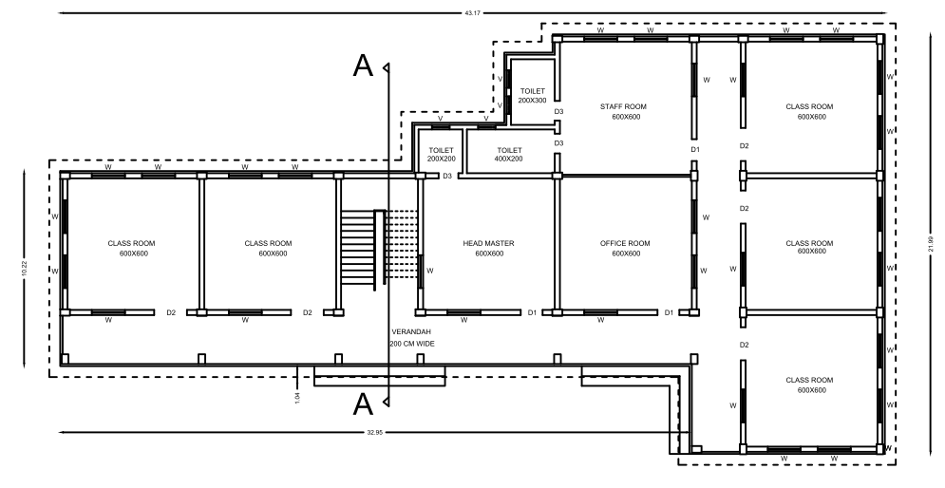

Fig 2.3 Ground floor plan

* 1. **FIRST FLOOR PLAN**

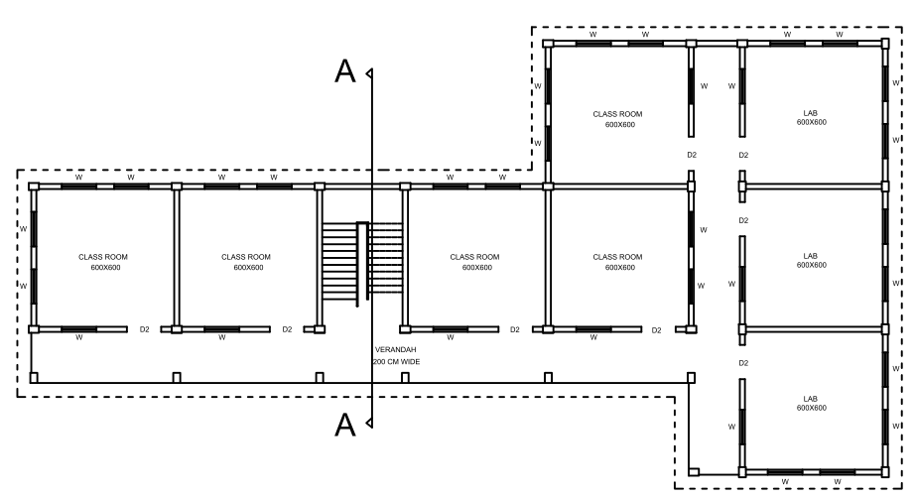

Fig 2.4 First floor plan

* 1. **SECTIONAL VIEW**

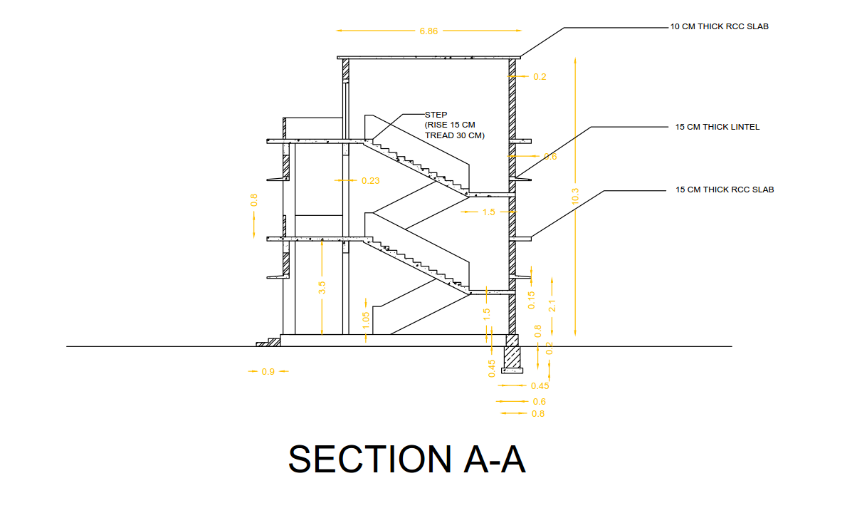

Fig 2.5 Section

* 1. **3D VIEW**

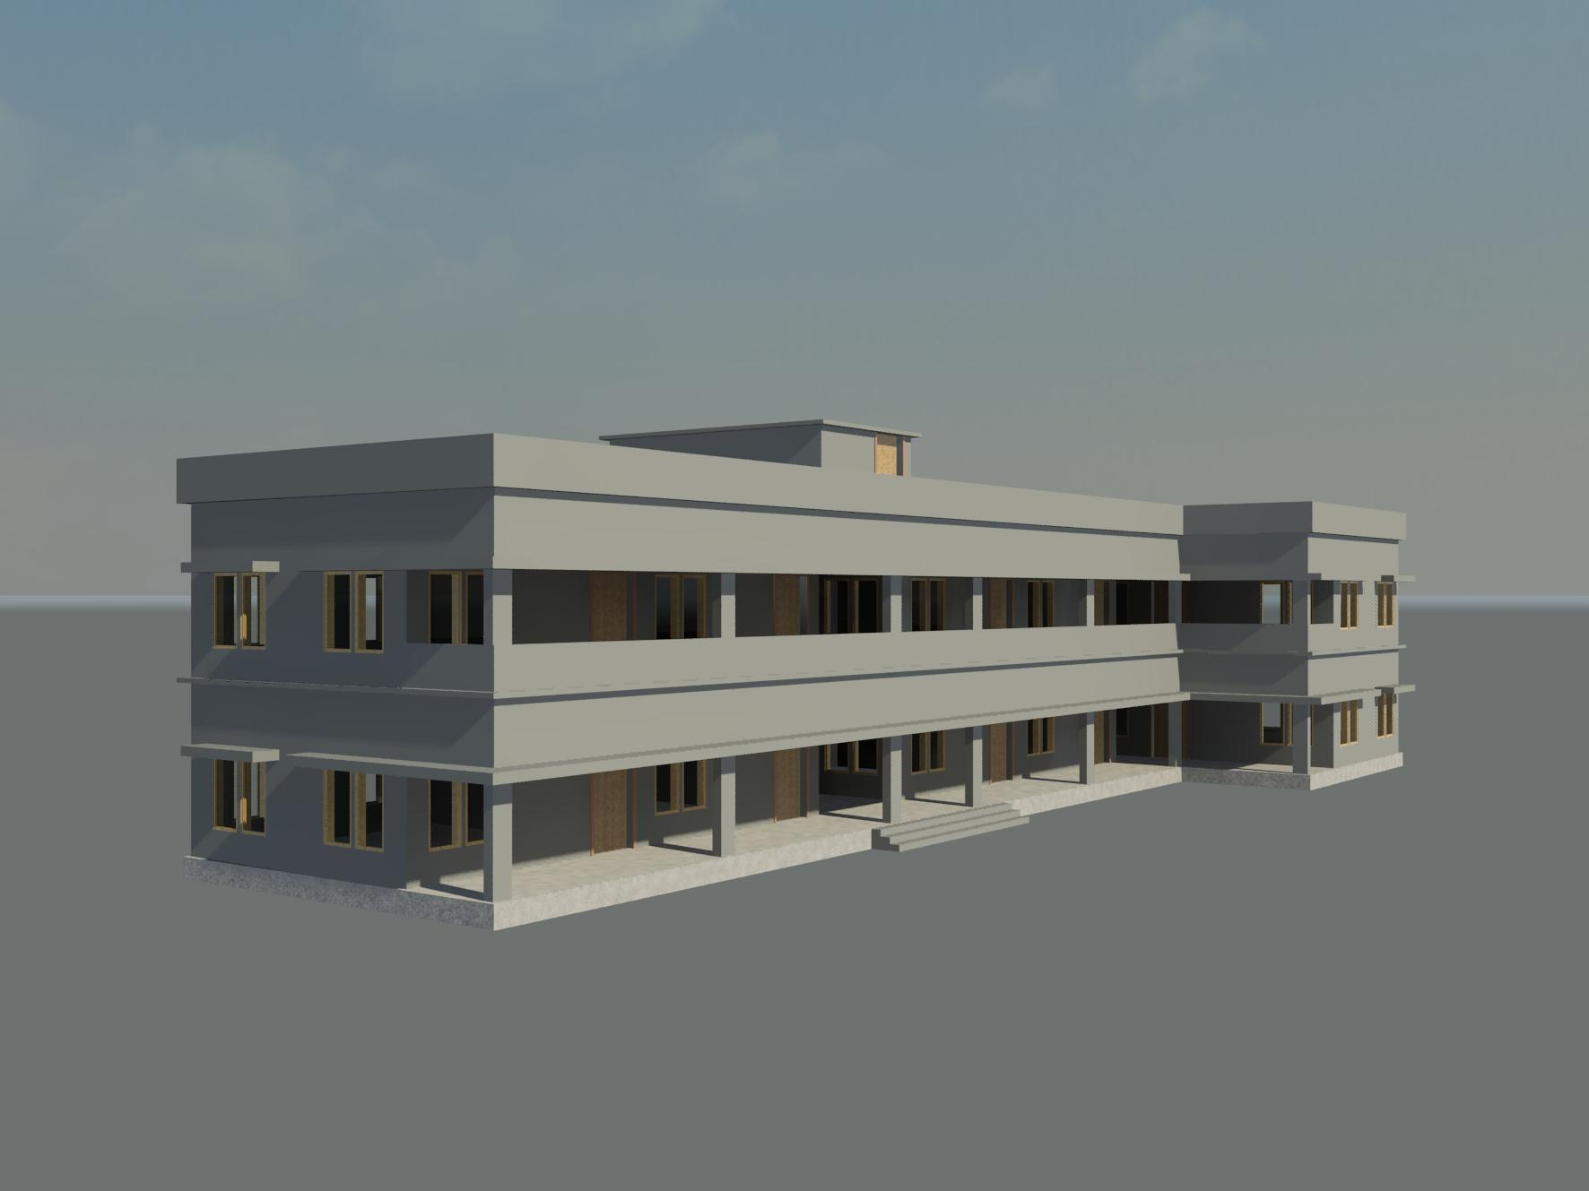

Fig 2.6 3D View

**CHAPTER 3**

**ANALYSIS OF STRUCTURE**

**3.1 ANALYSIS OF BEAM AND COLUMN**

**LOAD CALCULATION**

Weight of slab = 3.75 kN/m2

Floor finish = 1kN/m2

Live load is not considered in Top floor.

Total load = 4.75 kN/m2

Total load = (area x load)

= ( x 6.23 x 3.12) 4.75

= 46.1643kN

UDL =

= 7.41kN/m

LL = UDL = ( x 6.23 x 3.12) x 5

= 48.594kN

UDL =

= 7.8kN/m

Self weight of the beam = 0.45 x 0.3 x 25

= 3.375kN/m

Brick load = 3.5 x 0.23 x 19

= 15.295kN/m

**CASE 1 : MOMENT DUE TO LL ON AB & CD**



Dead load = UDL + self weight of beam

= 7.41 + 3.375

= 10.785kN/m

Dead load + live load = 10.785 + 7.8

= 18.585kN/m

FEM due to DL =

=

= 34.883kNm

Factored moment = 34.883 x 1.5

= 52.324kNm

FEM due to (DL + LL) =

= 60.111kNm

Factored moment = 60.111 x 1.5

= 90.167kNm

DESIGN MOMENT IN BEAM

|  |  |  |  |  |  |  |
| --- | --- | --- | --- | --- | --- | --- |
| JOINT | A | B | | C | | D |
| MEMBER | AB | BA | BC | CB | CD | DC |
| DF | 0.359 | 0.265 | 0.265 | 0.265 | 0.265 | 0.359 |
| FEM | -90.167 | 90.167 | -90.167 | 90.167 | -90.167 | 90.167 |
| BAL | 32.367 | -10.028 | 10.028 | -10.028 | 10.028 | -32.369 |
| COM | -5.014 | 16.184 | -5.014 | 5.014 | -16.184 | 5.014 |
| BM | 1.80 | -5.617 | -1.160 | 1.160 | 5.617 | -1.80 |
|  |  |  |  |  |  |  |
| Final Moment | -61.012 | 90.706 | -86.313 | 86.313 | -90.711 | 61.012 |
| Free Moment at Centre of Span | 90.167 | | 90.167 | | 90.167 | |
| Mid Span Moment | 14.308 | | 3.854 | | 14.305 | |

Table 3.1 Design moment in top floor beam

DESIGN MOMENT IN COLUMN

|  |  |  |  |  |  |  |
| --- | --- | --- | --- | --- | --- | --- |
| **JOINTS** | **A** | **B** | | **C** | | **D** |
| MEMBER | AE’ | BF’ | | CG’ | | DH’ |
| DF | 0.64 | 0.47 | | 0.47 | | 0.64 |
| FEM | -90.167 | 90.167 | -52.32 | 52.32 | -90.167 | 90.167 |
| COM | -5.014 | 16.18 | 5.014 | -5.014 | -16.18 | 5.014 |
| FEM + COM | -95.181 | 59.014 | | -59.014 | | 95.181 |
| COLUMN MOMENT | 60.915 | -27.749 | | 27.749 | | -60.915 |

Table 3.2 Design Moment in Top Floor Column

**CASE 2 : MOMENT DUE TO LL ON BC ONLY**

DESIGN MOMENT IN BEAM

Table 3.3 Design moment in top floor beam

|  |  |  |  |  |  |  |
| --- | --- | --- | --- | --- | --- | --- |
| JOINT | A | B | | C | | D |
| MEMBER | AB | BA | BC | CB | CD | DC |
| DF | .359 | .265 | .265 | .265 | .265 | .359 |
| FEM | -52.324 | 52.324 | -90.167 | 90.167 | -52.324 | 52.324 |
| BAL | 18.784 | 10.028 | 10.028 | -10.028 | -10.028 | -18.784 |
| COM | 5.014 | 9.392 | -5.014 | 5.014 | -9.392 | -5.014 |
| BAL | -1.80 | -1.160 | -1.160 | 1.160 | 1.160 | 1.80 |
| Final Moment | -30.326 | 70.584 | -86.313 | 86.313 | -70.584 | 30.326 |
| Free Moment at Centre of Span | 52.324 | | 90.167 | | 52.324 | |
| Mid Span Moment | 1.869 | | 3.854 | | 1.869 | |

DESIGN MOMENT IN COLUMN

|  |  |  |  |  |  |  |
| --- | --- | --- | --- | --- | --- | --- |
| **JOINTS** | **A** | **B** | | **C** | | **D** |
| MEMBER | AE’ | BF’ | | CG’ | | DH’ |
| DF | 0.64 | 0.47 | | 0.47 | | 0.64 |
| FEM | -52.324 | 52.324 | -90.167 | 90.167 | -52.324 | 52.324 |
| COM | 5.014 | 9.392 | -5.014 | 5.014 | -9.392 | -5.014 |
| FEM + COM | -47.31 | -33.465 | | 33.465 | | 47.31 |
| COLUMN MOMENT | 30.278 | 15.728 | | -15.728 | | -30.278 |

Table 3.4 Design moment in top floor column

CASE 1: FIRST FLOOR MOMENT DUE TO LL ON EF & GH

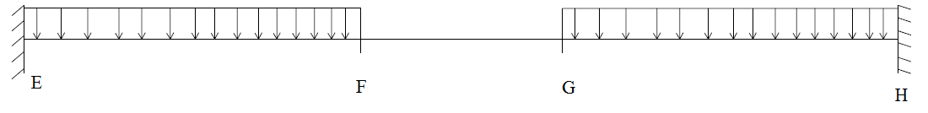

DL of second floor = 10.785 + brick work

= 10.785 + 15.295

= 26.08kN/m

DL + LL = 26.08 + 7.8

= 33.88kN/m

FEM due to DL =

= 84.353kNm

Factored moment = 84.353 x 1.5

= 126.53kNm

FEM due to (DL + LL) =

= 109.581kNm

Factored moment = 109.581 x 1.5

= 164.372kNm

DESIGN MOMENT IN BEAM

|  |  |  |  |  |  |  |
| --- | --- | --- | --- | --- | --- | --- |
| JOINT | E | F | | G | | H |
| MEMBER | EF | FE | FG | GF | GH | HG |
| DF | .359 | .265 | .265 | .265 | .265 | .359 |
| FEM | -164.372 | 164.372 | 126.33 | 126.33 | -164.372 | 164.372 |
| BAL | 59 | -10.08 | -10.08 | 10.08 | 10.08 | -59 |
| COM | -5.04 | 29.5 | 5.04 | -5.04 | -29.5 | 5.04 |
| BAL | 1.809 | -9.146 | -9.146 | 9.146 | 9.146 | -1.804 |
| Final Moment | -108.603 | 174.646 | -140.516 | 140.516 | -174.647 | 108.603 |
| Free Moment at Centre of Span | 211.07 | | 162.478 | | 211.072 | |
| Mid Span Moment | 69.447 | | 21.962 | | 69.447 | |
|  |  | |  | |  | |

Table 3.5 Design moment in first floor beam

DESIGN MOMENT IN COLUMN

|  |  |  |  |  |  |  |
| --- | --- | --- | --- | --- | --- | --- |
| E | | F | | G | | H |
| FEM | -164.372 | 164.372 | -126.33 | 126.33 | -164.372 | 164.372 |
| COM | -5.04 | 29.5 | 5.04 | -5.04 | -29.5 | 5.04 |
| FEM + COM | -169.412 | 72.582 | 72.582 | -72.582 | -72.582 | 169.482 |

Table 3.6 Design Moment in First Floor Column

CASE 2 : MOMENT DUE TO LL ON FG ONLY

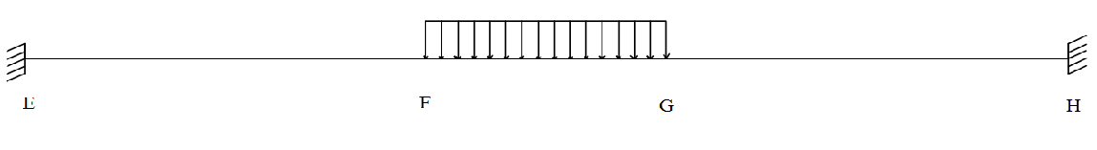

DESIGN MOMENT IN BEAM

Table 3.7 Design moment in first floor beam

|  |  |  |  |  |  |  |
| --- | --- | --- | --- | --- | --- | --- |
| JOINT | E | F | | G | | H |
| MEMBER | EF | FE | FG | GF | GH | HG |
| DF | .359 | .265 | .265 | .265 | .265 | .359 |
| FEM | -126.33 | 126.33 | 164.372 | 164.372 | -126.33 | 126.33 |
| BAL | 45.352 | 10.081 | 10.081 | -10.081 | -10.081 | -45.352 |
| COM | 5.040 | 22.676 | -5.040 | 5.040 | -22.676 | -5.040 |
| BAL | -1.809 | -4.674 | -4.674 | 4.674 | 4.674 | 1.809 |
| Final Moment | -77.747 | 154.412 | -164 | 164 | 154.413 | 77.747 |
| Free Moment at Centre of Span | 162.478 | | 211.072 | | 162.478 | |
| Mid Span Moment | 46.398 | | 47.072 | | 46.398 | |
|  |  | |  | |  | |

DESIGN MOMENT IN COLUMN

|  |  |  |  |  |  |  |
| --- | --- | --- | --- | --- | --- | --- |
| E | | F | | G | | H |
| FEM | -126.333 | 126.33 | -164.372 | 164.372 | -126.33 | 126.33 |
| COM | 5.040 | 22.676 | -5.040 | 5.040 | -22.676 | -5.040 |
| FEM + COM | -121.29 | -20.406 | -20.406 | 20.406 | 20.406 | 121.29 |

Table 3.8 Design moment in first floor column

Comparison between Manual and STAAD Analysis

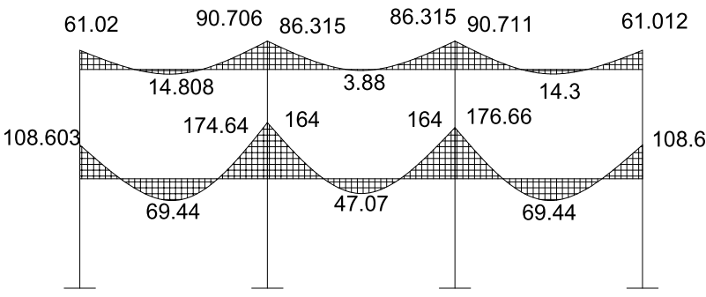

Fig 3.1 Result From Manual Analysis

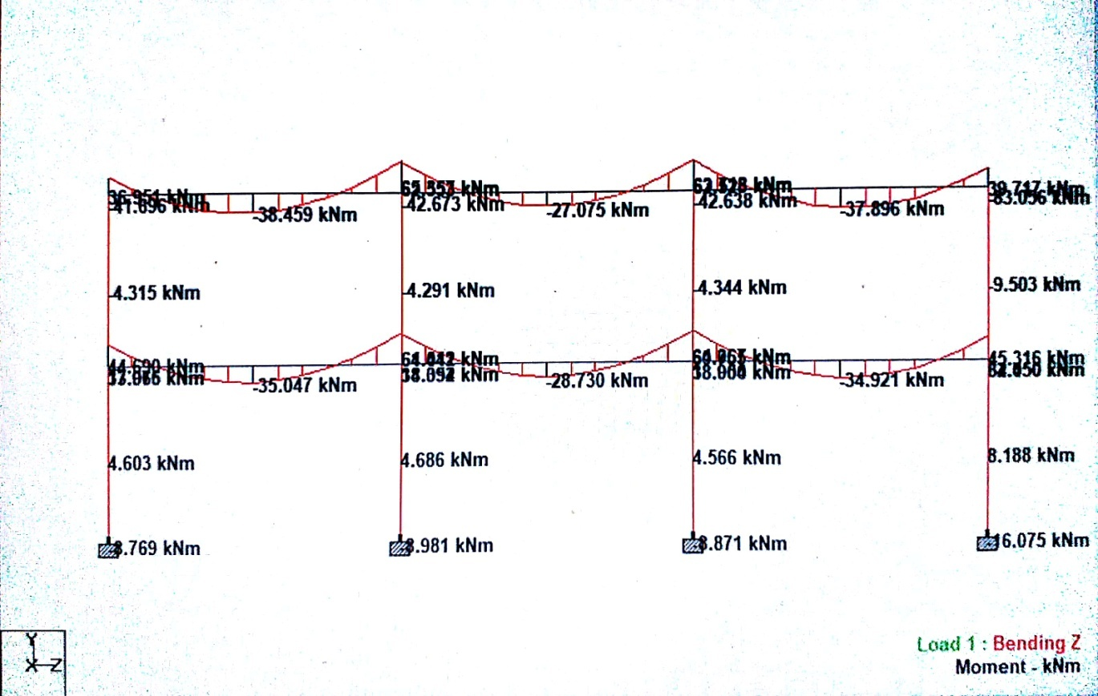

Fig 3.2 Result from STAAD analysis

**CHAPTER 4**

**DESIGN OF STRUCTURAL ELEMENTS**

* 1. **DESIGN OF SLAB**
     1. **Two Adjacent Edge Discontinuous**

Fy = 415 N/mm2

Live load = 4 k N/m2

Floor finish = 1 k N/m2

Wall thickness = 23cm

Size = 6 x 6 m

=

= 1< 2

Slab is designed as two way slab

**Effective depth calculation**

d =

=

= 171.43 mm

Take effective depth (d) =150 mm

Provide an effective cover of 25 mm

Over all depth = 150+25

= 175 mm

**Effective span calculation**

Lx = clear span +l eff depth

= 6+0.15

= 6.15 m

Ly = clear span + l eff depth

= 6+0.15

=6.15 m

**Load calculation**

Dead load = b x D x 25

= 1x0.175x 25

= 4.375 k N/m

Live load = 4 k N/m

Floor finish = 1 k N/m

Total load = 4.375+4+1

=9.375 k N/m

Factored load = 9.375 x1.5

= 14.063 k N/m

**BM calculation**

Find condition :-two adjacent edges discontinuous

=

= 1

**Bending moments calculation**

Mux(+ve)= xWulx2

= 0.035*14.063*6.15^2

= 18.616kNm

Mux(-ve)=xWulx2

=0.047*14.063*6.15^2

=24.999kNm

**Effective depth calculation**

d =

=

=95.171mm

Provide d = 150mm

D = 175mm

**Area of steel calculation**

* Ast(top of support –ve)

Mu = 0.87fyAst x d (1-(fyAst)/(fckbd**)**)

=0.87*415*Ast*150(1-(415*Ast)/(20*1000*150))

Ast =495.573mm2

Provide 10mm Ø bar

Spacing =

=

=158.483mm

Maximum spacing = 300mm

There for provide 10mm Ø bars @ 150mm c/c in shorter direction

Ast provided =

= 523.599mm2

* Ast(top of support +ve)

Mu = 0.87fy Ast d (1-(fy Ast)/(fck b d**)**)

=0.87*415*Ast*150(1-(415*Ast)/(20*1000*150))

=361.852mm2

Provide 10mm Ø bar

Spacing =

=

=217.049mm

Maximum spacing = 300mm

There for provide 10mm Ø bars @ 210mm c/c in shorter direction

Ast provided =

= 373.999mm2

**Torsional reinforcement**

Size of torsion mesh = lx/5 xly/5

= 6.15/5 x 6.15/5

= 1.23x1.23m

At each corner two meshes one @ top and other @ bottom are to be provided

Area of torsion steel = ¾ (Astx)

Ast torsion = 3/4x523.599=392.699mm2

Provide 8 mm Ø bars @ a spacing of =

=

=128mm

Provide 8 mm Ø bars @ a spacing of 120mm c/c

**Check for shear**

Design shear force = wu lx/2

= 14.063x6.15/2

Vu = 43.244kN

Nominal shear stress (v) = vu/bd

=

=0.288N/mm2

Permissible shear stress c

Pt =

=

= 0.349 %

c = 0.408 N/mm2 from IS 456 : 2000 table 19

v <c

Shear is safe

**Check for development length**

Ld =

=k, k is based on characteristic strength of steel, concrete bond stress. From table k=47

= 376mm

M1 = 0.87fyAst x d (1-(fyAst)/(fckbd))

= 0.87x415x523.599x150 (1-(415x523.599)/(20x1000x150))

= 26.303kNm

Lo = support width /2 –cover

= – 20

= 95

+ Lo = + 95

= 885.720mm

Ld< + Lo

Development length is also safe

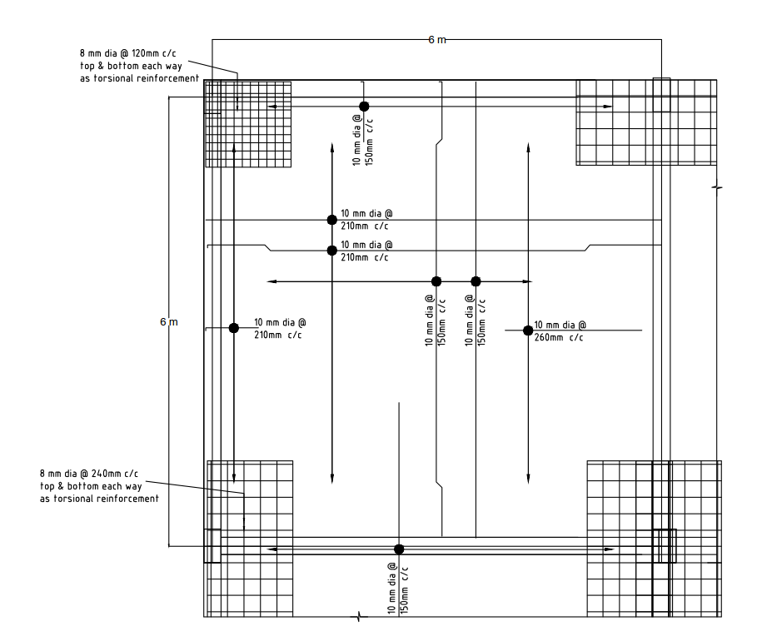

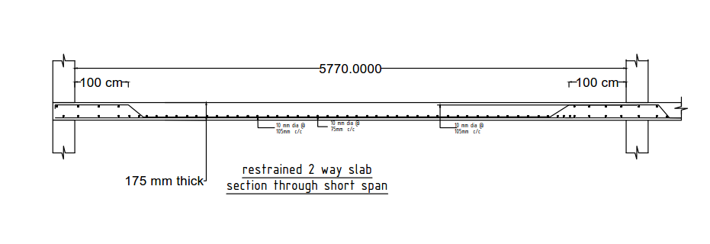

Fig 4.1 Plan and Section of Slab 1

* + 1. **Simply Supported On Four Ends**

Fy = 415 N/mm2

Live load = 4 k N/m2

Floor finish = 1 k N/m2

Wall thickness = 23cm

Size = 6 x 6 m

=

= 1< 2

Slab is designed as two way slab

**Effective depth calculation**

d =

=

= 171.43 mm

Take effective depth (d) =150 mm

Provide an effective cover of 25 mm

Over all depth = 150+25

= 175 mm

**Effective span calculation**

Lx = clear span +l eff depth

= 6+0.15

= 6.15 m

Ly = clear span + l eff depth

= 6+0.15

=6.15 m

**Load calculation**

Dead load = b x D x 25

= 1x0.175x 25

= 4.375 k N/m

Live load = 4 k N/m

Floor finish = 1 k N/m

Total load = 4.375+4+1

=9.375 k N/m

Factored load = 9.375 x1.5

= 14.063 k N/m

**BM calculation**

Find condition :-simply supported on four edges

=

= 1

**Bending moments calculation**

Mux(+ve)= xWulx2

= 0.062*14.063*6.15^2

= 32.978kNm

**Effective depth calculation**

d =

=

=109.309mm

Provide d = 150mm

D = 175mm

**Area of steel calculation**

Ast

Mu = 0.87fyAst x d (1-(fyAst)/(fckbd**)**)

= 0.87*415*Ast*150(1-(415*Ast)/(20*1000*150))

Ast =671.241mm2

Provide 12mm Ø bar

Spacing =

=

=168.489mm

Maximum spacing = 300mm

There for provide 12mm Ø bars @ 160mm c/c in shorter direction

Ast provided =

= 706.858mm2

**Check for shear**

Design shear force = wu lx/2

= 14.063x6.15/2

Vu = 43.244k N

Nominal shear stress (v) = vu/bd

=

=0.288N/mm2

Permissible shear stress c

Pt =

=

= 0.471 %

c = 0.364 N/mm2

v <c

Shear is safe

**Check for development length**

Ld =

=k, k is based on characteristic strength of steel, concrete bond stress. From table k=47

= 376mm

M1 = 0.87fyAst x d (1-(fyAst)/(fckbd))

= 0.87x415x392.699x150 (1-(415x392.699)/(20x1000x150))

= 20.119kNm

Lo = support width /2 –cover

= – 20

= 95

= + Lo = + 95

= 699.82mm

Ld< + Lo

Development length is also safe

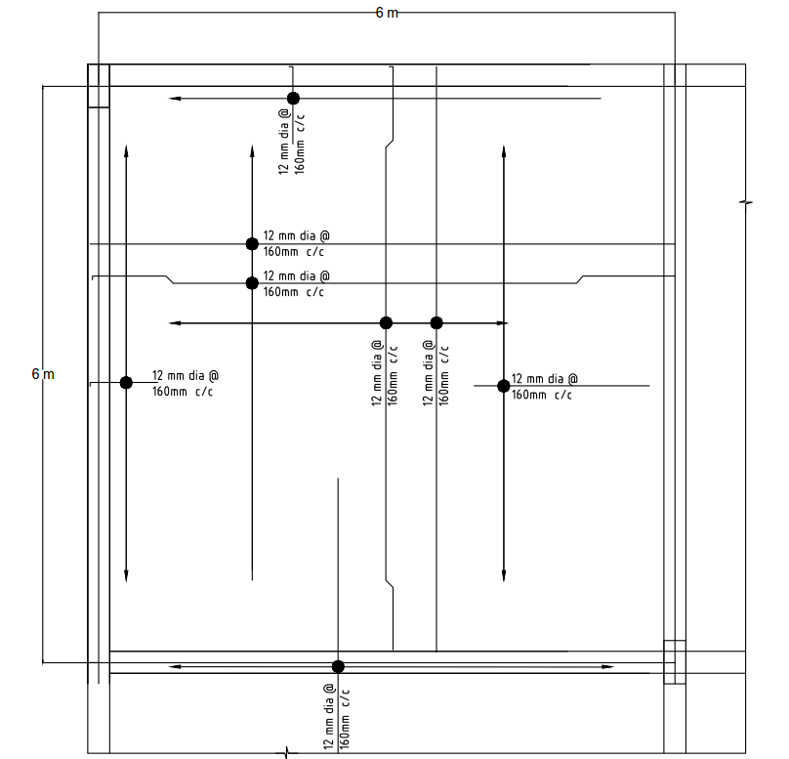

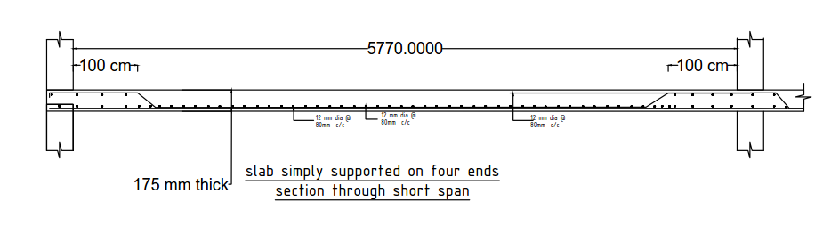

Fig 4.2 Plan and Section of Slab 2

* + 1. **Simply Supported On Four Sides**

Fy = 415 N/mm2

Live load = 4 k N/m2

Floor finish = 1 k N/m2

Wall thickness = 23cm

Size = 3.5 x 6 m

=

= 1.714< 2

Slab is designed as two way slab

**Effective depth calculation**

d =

=

= 125mm

Take effective depth (d) =120mm

Provide an effective cover of 25mm

Over all depth = 120+25

= 145mm

**Effective span calculation**

Lx = clear span +l eff depth

= 3.5+0.145

= 3.645m

Ly = clear span + l eff depth

= 6+0.145

=6.145m

**Load calculation**

Dead load = b x Dx 25

= 1x0.145x 25

= 3.625k N/m

Live load = 4 k N/m

Floor finish = 1 k N/m

Total load = 3.625+4+1

=8.625 k N/m

Factored load = 8.625 x1.5

= 12.94 k N/m

**BM calculation**

Find condition :-simply supported on four sides

=

= 1.686

**Short span bending moments calculation**

Mux = xWulx2

= 0.111*12.94*3.5^2

= 17.595kNm

**Long span bending moments calculation**

Mux = yWulx2

= 0.0393*12.94*3.5^2

= 6.229kNm

**Effective depth calculation**

d =

=

= 79.84mm

Provided = 100mm< 120mm hence safe

**Area of steel calculation**

* **For shorter span**

Astx

Mu = 0.87fyAst x d (1-(fyAst)/(fckbd**)**)

= 0.87*415*Ast*120(1-(415*Ast)/(20*1000*120))

Ast = 439.51mm2

Provide 8mm Ø bar

Spacing =

=

=114.367mm

Maximum spacing = 300mm

There for provide 8mm Ø bars @ 110mm c/c in shorter direction

Astx provided =

= 456.959mm2

* **For longer span**

Asty

Mu = 0.87fyAst x d (1-(fyAst)/(fckbd**)**)

= 0.87*415*Ast*120(1-(415*Ast)/(20*1000*120))

Ast = 147.534mm2

Provide 8mm Ø bar

Spacing =

=

=340.70mm

Maximum spacing = 300mm

There for provide 8mm Ø bars @ 300mm c/c in longer direction

Asty provided =

= 167.46mm2

**Check for shear**

Design shear force = wu lx/2

= 12.94x3.5/2

Vu = 22.645k N

Nominal shear stress (v) = vu/bd

=

=0.226N/mm2

Permissible shear stress c

Pt =

=

= 0.251 %

c = 0.361 N/mm2

v <c

Shear is safe

**Check for development length**

Ld =

=k, k is based on characteristic strength of steel, concrete bond stress. From table k=47

= 376mm

M1 = 0.87fyAst x d (1-(fyAst)/(fckbd))

= 0.87x415x456.959x120 (1-(415x456.959)/(20x1000x120))

= 18.234kNm

Lo = support width /2 –cover

= – 25

= 90

= + Lo = + 90

= 1136.774mm

Ld< + Lo

Development length is also safe

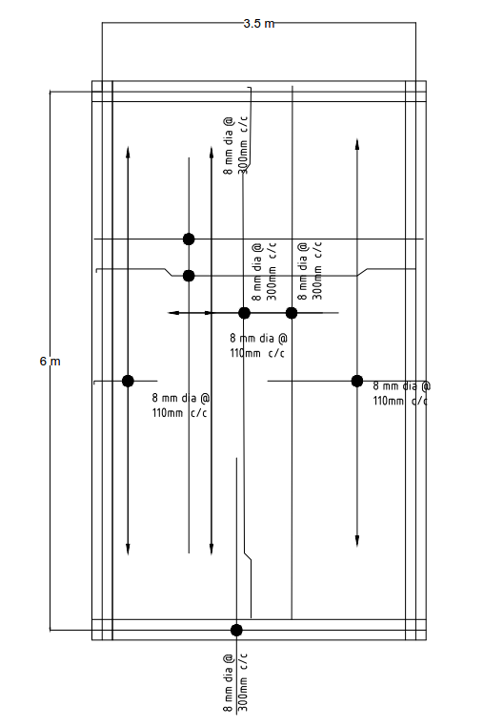

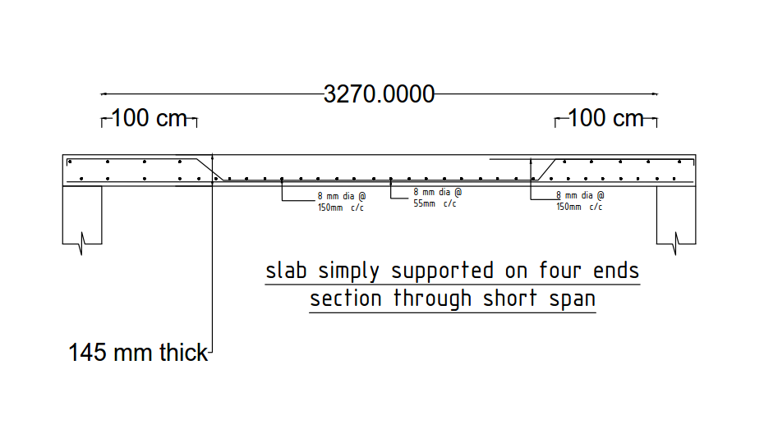

Fig 4.3 Plan and Section of Slab 3

**4.2 DESIGN OF BEAMS:**

**Given data:**

bf = 1450 mm

bw = 450 mm

Overall depth D = 300 mm

Effective depth d = 275 mm

Df = 50 mm

Fy = 415

Fck = 25

Assume Xu = Df

**LOADS ON BEAMS:**

Span = 6 m

Assuming beam size = 450x300mm

**Load calculations**

Wall load =0.23x 3.5x 19 =15.295N/m

Self load = 0.45x 0.3 x 25 =3.375kN/m

Slab load = = = 14kN/m

Total load = 15.295+3.375+14=32.67 kN/m

**Moment calculations**

Max Mu at end span = 83.056 x 1.5 kN-m

= 124.584kN-m

Max Mu at Mid span = 38.459 x 1.5 kN-m

= 57.6885kN-m

**Check**

Calculation of limiting moment of resistances:

Mu = 124.584 KN-m

= 141.052kN-m

Mu < Mulimit

Hence it is designed as Singly reinforced beam .

**AREA OF REINFORCEMENT**

**For End moment**

Mu = 0.87 fy Astd

124.584 x 106= 0.87 x 415 x Ast x 275 x

Ast = 1267.75 mm2

Provide 20 mm dia bar

No: of bars =

=

= 4 bars

Hence provide 4 bars of 20 mm dia.

**For mid span moment**

Mu = 0.87 fy Astd

87.73 x 106 = 0.87 x 415 x Ast x 425 x

Ast = 583.77 mm2

Provide 20 mm dia bar

No: of bars =

= =2

Hence provide 2 bars of 20 mm dia.

**DESIGN OF STIRRUPS**

**Calculation of shear force**

Shear force Vu =

=

= 98.01 kN

**Calculation of normal shear**

=

=

= .792

**Calculation of permissible shear stress**

=

Ptlimt =x 100

= x 100

= 0.47

0.47 0.792

Hence provide shear reinforcement.

**Design of shear:**

Vus = (-) bd

= x 450 x 275

= 39847.5

= 39847.5 x 1.5

= 59771.25 kN

Provide 8 mm dia bar

Asv = x x 2 = 100.53 mm2

For vertical stirrups

Vus =

59771.25 =

= 166.99 mm

Hence provide 8mm dia @ 150 mm c/c spacing.

**Check for spacing:**

Spacing should be provided min of the following.

(a) 0.75d = 0.75 x 275 = 206.25 mm

(b) = = 231.77 mm

© design spacing 150 mm c/c

Hence provide 8mm dia stirrups @ 150 cm c/c.

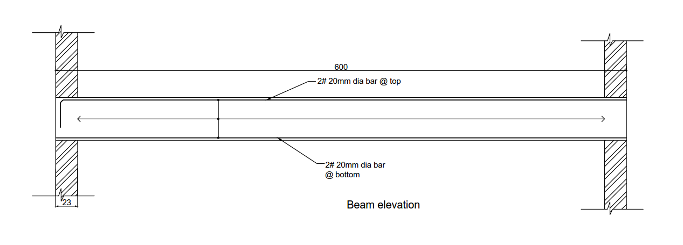

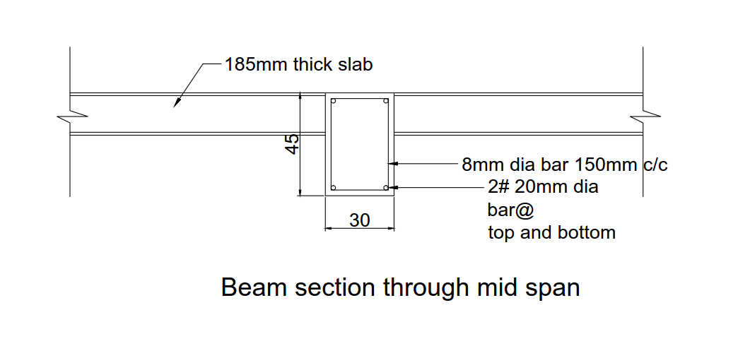

Fig 4.4 Elevation and Section of Beam

**4.3 DESIGN OF COLUMN**

**Short Column Biaxial Bending**

Given data:

Length of column = = 3.5 m

Width of column = b = 0.3 m

Effective length of column = = 0.65 = 2.275 m

= 25

= 415

= 1790.18kN

= 89.24kNm

= 57kNm

le = 0.65 = 2.275 m

Slenderness Ratio

le/b = 7.583 < 12

Therefore it is an axially loaded short column with biaxial bending

= + 2

= + = 21.66

= 21.66 mm

= = = 49.85 >

= = = 31.84

Therefore design the beam with axial loading and biaxial bending.

Assume P = .93

= x 300 x 450 = 1255.5 mm2

Provide 4 bars of 20 mm dia.

= 1256 m

= = 0.037

= = 0.088

Chart for d’/D = 0.1 will be used.

= = 0.53

From SP-16

= 0.01

= 0.01

= 0.01 x 25 x 450 x 3002

= 101.25kNm

= 0.01 x 25 x 4502 x 300

= 151.88kNm

= (0.45 ) + ( 0.75 )

= (0.45 x 25 x ( (450 x 300 ) - 1256 )) + ( 0.75 x 415 x 1256 )

= 1541.18kN

= = 1.16

= 2 (From IS 456:2000 clause 39.6)

+ 1

+ = 0.92 1

Therefore it is safe.

Spacing or this is

1. 16 d = 16 x 20 = 320 mm

2. 230 mm

3. 300 mm

Therefore minimum spacing is 230 mm

Hence, provide 10 dia bar @ 210 c/ c.

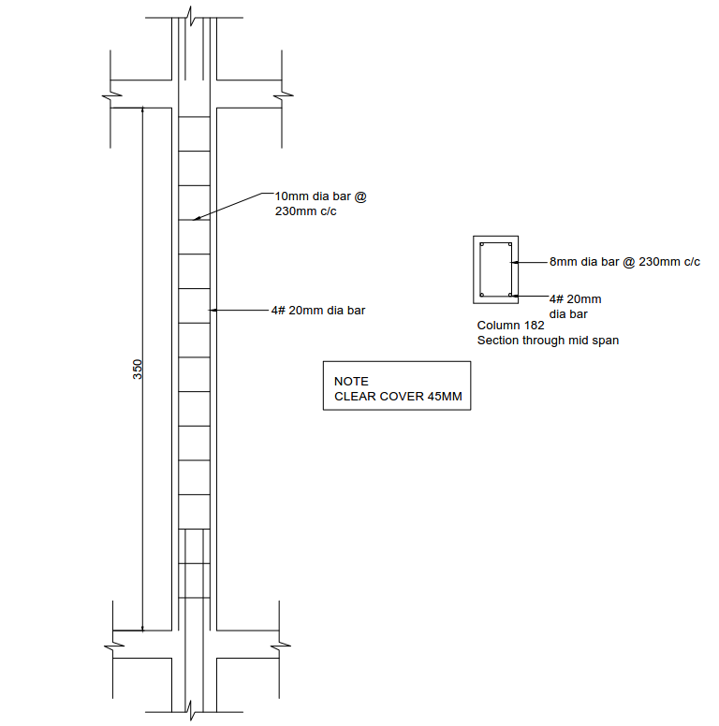

Fig 4.5 Elevation and Section of Column

**4.4 DESIGN OF THE STAIR**

Stairs consist of steps arranged in a series for purpose of giving access to different floors of a building. Since a stair is often the only means of communication between the various floors of a building, the location of the stair requires good and careful consideration. In a residential house, the staircase may be provided near the main entrance. In a public building, the stairs must be from the main entrance itself and located centrally, to provide quick accessibility to the principal apartments. All staircases should be adequately lighted and properly ventilated.

Various types of Staircases

1. Straight stairs
2. Dog-legged stairs
3. Open newel stair
4. Geometrical stair

RCC design of a Dog-legged staircase

In this type of staircase, the succeeding flights rise in opposite directions. The two flights in plan are not separated by a well. A landing is provided corresponding to the level at which the direction of the flight changes.

**4.4.1 Design Of First Flight**

Rise = 150mm

Tread = 300mm

fck = 20 N/mm2

fy = 415 N/mm2

No:of steps = 12

Live load = 4 kN/m

Width of landing beam = 400mm

**Effective Span Calculation**

L = (no:of steps x tread) + width of landing beam

= (12x300) + 400

= 4000mm = 4m

Thickness of waist slab =

=

= 200mm

**Dead load of the slab on horizontal span**

ws = w , =

ws = dead load on slab on slope

= 0.2 x 1 x 25

= 5kN/m

w = ws

=

= 5.59kN/m

Dead load of one step = x R x T x 25

= 0.5x0.15x0.3x25

= .563 kN

Dead load of step per m length =

= 1.877kN/m

Floor finish = 1 kN/m

Total load = w + D.L + L.L + F.F

= 5.59+1.877+4+1

= 12.467kN/m

wu = 1.5 x 12.467

= 18.701kN/m

Bending moment, Mu = wu l2 /8

=

= 37.402 kNm

Mu  lim = 0.138 x fck x b x d2

d2 =

= 13551.449

d = 116.41mm < 200mm

hence slab is safe

d = t = 200mm

Main steel

Mu  = 0.87 fy Ast d [ 1- ( ) ]

37.402 x 106 = 0.87 x 415 x Ast x 200 [ 1- ( ) ]

Ast = 549.279 mm2

Check

Min Ast = x b x D D = t+ R ,

= 200+ 150 = 334.164 = 340

= x 1000 x 340

= 408mm2 < Ast

Therefore the slab is safe

Provide 12mm dia bar

No : of bars =

=

= 4.85

= 5

Spacing b/w main bars = x 1000

= x 1000

= 200mm c/c

provide 12mm ø bars @ 200mm c/c

**Distribution steel**

Min Ast = x b x D

= x 1000 x 340

= 408mm2

Provide 10mm dia bar

Spacing b/w main bars = x 1000

= x 1000

= 192.499mm

Provide 10mm ø bars @ 190mm c/c

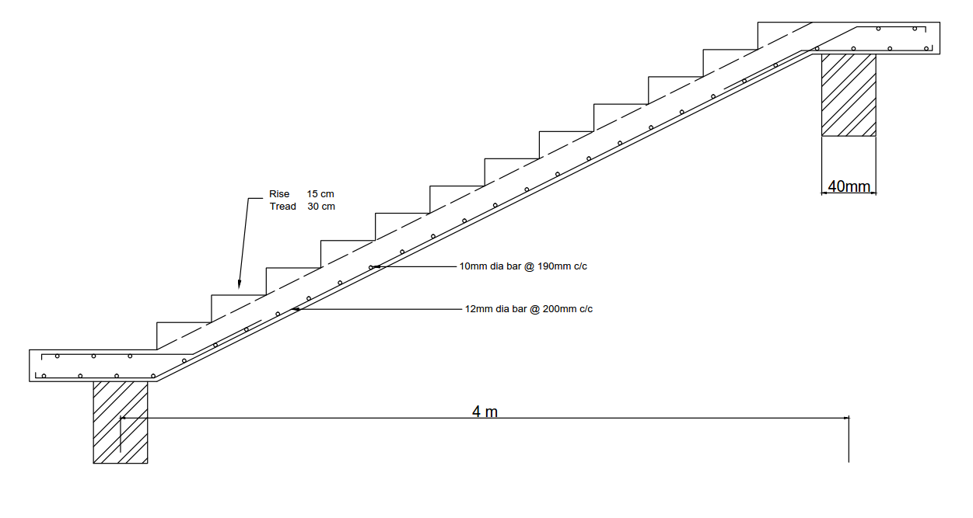

Fig 4.6 Section of Stair Flight

**4.4.2 Design Of Second Flight**

Rise = 150mm

Tread = 300mm

fck = 20 N/mm2

fy = 415 N/mm2

No:of steps = 11

Live load = 4 kN/m

Width of landing beam = 400mm

**Effective Span Calculation**

L = (no:of steps x tread) + width of landing beam

= (11x300) + 400

= 3700mm = 3.7m

Thickness of waist slab =

=

= 185mm

**Dead load of the slab on horizontal span**

ws = w , =

ws = dead load on slab on slope

= 0.185 x 1 x 25

= 4.625kN/m

w = ws

=

= 5.171kN/m

Dead load of one step = x R x T x 25

= 0.5x0.15x0.3x25

= .563 kN

Dead load of step per m length =

= 1.877kN/m

Floor finish = 1 kN/m

Total load = w + D.L + L.L + F.F

= 5.171+1.877+4+1

= 12.048kN/m

wu = 1.5 x 12.048

= 18.072kN/m

Bending moment , Mu = wu l2 /8

=

= 30.926 kNm

Mu  lim = 0.138 x fck x b x d2

d2 =

= 11205.072

d = 105.85mm < 185mm

hence slab is safe

d = t = 185mm

**Main steel**

Mu  = 0.87 fy Ast d [ 1- ( ) ]

30.926 x 106  = 0.87 x 415 x Ast x 185 [ 1- ( ) ]

Ast = 489.936 mm2

Check

Min Ast = x b x D D = t+ R ,

= 185+ 150 = 319.164 = 320mm

= x 1000 x 320

= 384mm2 < Ast

Therefore the slab is safe

Provide 12mm dia bar

No : of bars =

=

= 4.33

= 5

Spacing b/w main bars = x 1000

= x 1000

= 200mm c/c

provide 12mm ø bars @ 200mm c/c

**Distribution steel**

Min Ast = x b x D

= x 1000 x 320

= 384mm2

Provide 10mm dia bar

Spacing b/w main bars = x 1000

= x 1000

= 204.53mm

Provide 10mm ø bars @ 200mm c/c

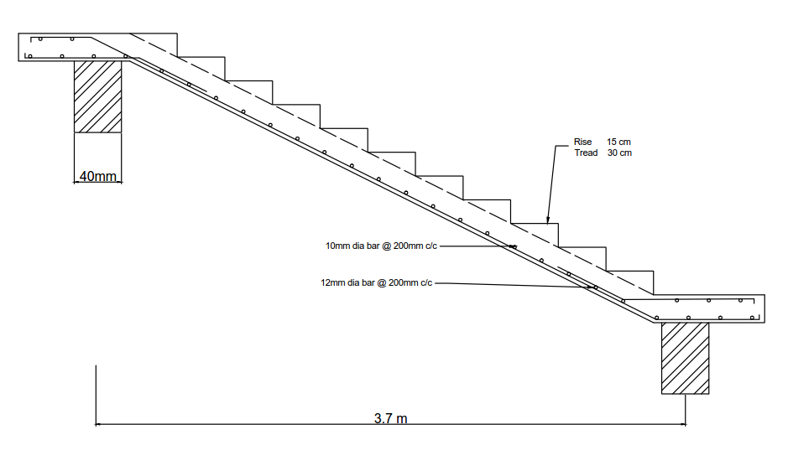

Fig 4.7 Section of Stair Flight

**4.4.3 Design Of Step**

b =

=

= 335.41mm

D = t+ R

= 200+

= 334.164mm

= 340mm , d =

d = 170mm

Load Calculation

Dead load of each step = x R x T x 25

= 0.5 x 0.15 x 0.30 x 25

= .5625kN/m

Live load = 4 x 0.3

= 1.2kN/m

Floor finish = 1kN/m

D.L of waist slab per m width of stair = b x t x 25 x 1

= 0.33541 x 0.20 x 25

= 1.675kN/m

Total load = 1.675+0.3+1.2+0.5625

= 3.7375

= 3.74kN/m

wu = 1.5 x w

= 1.5 x 3.74

=5.61kN/m

Mu =

=

= 11.22kNm

Mu lim = 0.138 x fck x b x d2

= 0.138 x 20 x 335.41 x 1702

= 26.754kNm

Mu < Mu lim , it is a singly reinforced section

Mu = 0.87 fy Ast d [ 1- ( ) ]

11.22 x 106 = 0.87 x 415 x Ast x 170 [ 1- ( ) ]

182.80 = Ast – Ast x 3.64 x 10-4

Ast = 196.91mm2

Min Ast = x b x D

= x 335.41 x 340

= 136.84mm2

Provide 8mm dia bars

No : of bars =

=

= 3.91

= 4

Distribution Steel

Min Ast = x b x D

= x 335.41 x 340

= 136.84mm2

Provide 6mm dia bar

1. Spacing , S = 1000

= 1000

= 206.62mm

1. 3d = 3 x 170 = 510
2. 300mm

Provide 6mm dia bar @ 200mm c/c

**CHAPTER 5**

**ESTIMATION**

|  |  |  |  |  |  |  |  |
| --- | --- | --- | --- | --- | --- | --- | --- |
| Sl No | Description | No | Length | Breadth | Height | | Quantity |
| **1** | **FIRST CLASS BRICK WORK 1:6 IN CM** |  |  |  |  | |  |
| **GROUND FLOOR** | | | | | | | |
|  | Stair room | 1 | 19.92 | 0.23 | 3.5 | | 16.0356 |
|  | class room | 5 | 24.82 | 0.23 | 3.5 | | 99.9005 |
|  | Headmaster room | 1 | 24.82 | 0.23 | 3.5 | | 19.9801 |
|  | Staff room | 1 | 24.82 | 0.23 | 3.5 | | 19.9801 |
|  | office room | 1 | 24.82 | 0.23 | 3.5 | | 19.9801 |
|  | HM toilet | 1 | 8.83 | 0.23 | 3.5 | | 7.10815 |
|  | Gents toilet | 1 | 10.83 | 0.23 | 3.5 | | 8.71815 |
|  | Ladies toilet | 1 | 12.86 | 0.23 | 3.5 | | 10.3523 |
|  |  |  |  |  | Total | | 202.055 |
|  | **DEDUCTION** |  |  |  |  | |  |
|  | Door |  |  |  |  | |  |
|  | D1 | 3 | 1 | 0.23 | 2.1 | | 1.449 |
|  | D2 | 5 | 1.5 | 0.23 | 2.1 | | 3.6225 |
|  | D3 | 3 | 0.9 | 0.23 | 2.1 | | 1.3041 |
|  | Window |  |  |  |  | |  |
|  | W | 29 | 1.5 | 0.23 | 1.2 | | 12.006 |
|  | Ventilation | 4 | 0.8 | 0.23 | 0.7 | | 0.5152 |
|  | Extra walls added | 7 | 6.23 | 0.23 | 3.5 | | 35.10605 |
|  |  |  |  |  | Total | | 54.00285 |
|  | Brick work after deduction = 149 m3 | | | | | | |
|  |  |  |  |  |  | |  |
|  |  |  |  |  |  | |  |
| **FIRST FLOOR** | | | | | | | |
|  | Class room | 5 | 24.82 | 0.23 | 3.5 | | 99.9005 |
|  |  |  |  |  |  | |  |
|  | Laboratory | 3 | 24.82 | 0.23 | 3.5 | | 59.9403 |
|  |  |  |  |  |  | |  |
|  | Stair room | 1 | 19.92 | 0.23 | 3.5 | | 16.0356 |
|  |  |  |  |  |  | |  |
|  |  |  |  |  |  | |  |
|  |  |  |  |  |  | |  |
|  |  |  |  |  | Total | | 175.8764 |
|  |  |  |  |  |  | |  |
|  | **Deduction** |  |  |  |  | |  |
|  | DOOR |  |  |  |  | |  |
|  |  |  |  |  |  | |  |
|  | D2 | 8 | 1.5 | 0.23 | 2.1 | | 5.796 |
|  |  |  |  |  |  | |  |
|  | Window | 32 | 1.5 | 0.23 | 1.2 | | 13.248 |
|  |  |  |  |  |  | |  |
|  | Extra walls added | 7 | 6.23 | 0.23 | 3.5 | | 35.10605 |
|  |  |  |  |  | Total | | 54.15005 |
|  |  |  |  |  |  | |  |
|  | Brick work after deduction = 122 m3 | | | | | | |
|  |  |  |  |  |  | |  |
|  |  |  |  |  |  | |  |
|  |  | **GRAND TOTAL IN** m3  Say 271 m3 @ Rs 8,000/ = | | | | | 271  1,192,000.00 |
| 2 | **RCC 1:1.5:3** |  |  |  |  | |  |
| **GROUND FLOOR** | | | | | | | |
|  | **Column** |  |  |  |  |  | |
|  | C | 29 | 0.45 | 0.3 | 3.5 | 13.7025 | |
|  |  |  |  |  |  |  | |
|  |  |  |  |  | Total | 13.7025 | |
|  | **Lintel** |  |  |  |  |  | |
|  | Trough out the building | 1 | 177.9 | 0.23 | 0.15 | 6.13755 | |
|  |  |  |  |  |  |  | |
|  |  |  |  |  |  |  | |
|  |  |  |  |  | Total | 6.13755 | |
|  |  |  |  |  |  |  | |
|  | **Sunshade** | 1 | 116.49 | 0.6 | 0.15 | 10.4841 | |
|  |  |  |  |  |  |  | |
|  | **Roof slab** | 1 | 34.61 | 44.94 | 0.15 | 233.30601 | |
|  |  |  |  |  |  |  | |
|  |  | Roof slab = 234 m3 | | | |  | |
|  |  |  |  |  |  |  | |
|  |  |  |  |  |  |  | |
|  | **Beam** |  |  |  |  |  | |
|  | B1 | 32 | 6.23 | 0.23 | 0.35 | 16.04848 | |
|  | B2 | 2 | 3.73 | 0.23 | 0.45 | 0.77211 | |
|  | B3 | 8 | 2.12 | 0.23 | 0.45 | 1.75536 | |
|  |  | 6 | 2.12 | 0.23 | 0.3 | 0.87768 | |
|  |  |  |  |  | **Total** | 19.45363 | |
|  |  |  |  |  |  |  | |
| **FIRST FLOOR** | |  |  |  |  |  | |
|  | **Column** |  |  |  |  |  | |
|  | C | 29 | 0.45 | 0.3 | 3.5 | 13.7025 | |
|  |  |  |  |  |  |  | |
|  |  |  |  |  | Total | 13.7025 | |
|  | **Lintel** |  |  |  |  |  | |
|  | Trough out the building | 1 | 177.9 | 0.23 | 0.15 | 6.13755 | |
|  |  |  |  |  |  |  | |
|  |  |  |  |  |  |  | |
|  |  |  |  |  | Total | 6.13755 | |
|  |  |  |  |  |  |  | |
|  | **Sunshade** | 1 | 117.32 | 0.6 | 0.15 | 10.5588 | |
|  |  |  |  |  |  |  | |
|  | **Roof slab** | 1 | 35.44 | 41.04 | 0.15 | 218.16864 | |
|  |  |  |  |  |  |  | |
|  |  | Roof slab = 219 m3 | | | |  | |
|  |  |  |  |  |  |  | |
|  |  |  |  |  |  |  | |
|  | **Beam** |  |  |  |  |  | |
|  | B1 | 32 | 6.23 | 0.23 | 0.45 | 20.63376 | |
|  | B2 | 2 | 3.73 | 0.23 | 0.45 | 0.77211 | |
|  | B3 | 8 | 2.12 | 0.23 | 0.45 | 1.75536 | |
|  |  | 6 | 2.12 | 0.23 | 0.3 | 0.87768 | |
|  |  |  |  |  | **Total** | 24.03891 | |
|  |  |  |  |  |  |  | |
|  |  |  | **GRAND TOTAL**  Say 558.9 m3 @ Rs 16,000/ = | | | 558.9 m3  8,942,400.00 | |
| 3 | **BED CONCRETE 1:2:4** |  |  |  |  |  | |
|  | Office Room | 1 | 6 | 6 | 0.1 | 3.6 | |
|  | Head master room | 1 | 6 | 6 | 0.1 | 3.6 | |
|  | Staff room | 1 | 6 | 6 | 0.1 | 3.6 | |
|  | Class room | 5 | 6 | 6 | 0.1 | 18 | |
|  | Stair Room | 1 | 3.5 | 6 | 0.1 | 2.1 | |
|  | HM toilet | 1 | 2 | 2 | 0.1 | 0.4 | |
|  | Gents toilet | 1 | 2 | 3 | 0.1 | 0.6 | |
|  | Ladies toilet | 1 | 4 | 2 | 0.1 | 0.8 | |
|  | Passage | 1 | 28.765 | 2.23 | 0.1 | 6.414595 | |
|  |  | 1 | 18.67 | 2.23 | 0.1 | 4.16341 | |
|  |  |  |  | **GRAND TOTAL**  Say 43.28 m3 @ Rs16,000 / = | | 43.27801 m3  692,480.00 | |
| 4 | **PLASTERING 1:4 IN CM** |  |  |  |  |  | |
| **GROUND FLOOR** | |  |  |  |  |  | |
|  | Office Room | 4 | 5.93 |  | 3.5 | 83.02 | |
|  | Head master room | 4 | 5.93 |  | 3.5 | 83.02 | |
|  | Staff room | 4 | 5.93 |  | 3.5 | 83.02 | |
|  | Class room | 20 | 5.93 |  | 3.5 | 415.1 | |
|  | Stair room | 2 | 5.93 |  | 3.5 | 41.51 | |
|  |  | 1 | 3.28 |  | 3.5 | 11.48 | |
|  | HM Toilet | 4 | 2 |  | 3.5 | 28 | |
|  | Gents toilet | 2 | 2 |  | 3.5 | 14 | |
|  |  | 2 | 4 |  | 3.5 | 28 | |
|  | Ladies toilet | 2 | 2 |  | 3.5 | 14 | |
|  |  | 2 | 3 |  | 3.5 | 21 | |
|  | Passage | 9 | 5.93 |  | 3.5 | 186.795 | |
|  |  | 1 | 1.78 |  | 3.5 | 6.23 | |
|  | External walls | 10 | 5.93 |  | 3.5 | 207.55 | |
|  |  | 1 | 1.78 |  | 3.5 | 6.23 | |
|  |  | 2 | 2.2 |  | 3.5 | 15.4 | |
|  |  | 1 | 4.2 |  | 3.5 | 14.7 | |
|  |  | 1 | 3.28 |  | 3.5 | 11.48 | |
|  |  | 1 | 3.2 |  | 3.5 | 11.2 | |
|  |  |  |  |  | **Total** | 1184.995 | |
|  | **Column** |  |  |  |  |  | |
|  | C | 58 | 0.45 |  | 3.5 | 91.35 | |
|  |  | 58 | 0.3 |  | 3.5 | 60.9 | |
|  |  |  |  |  | **Total** | 152.25 | |
|  | **Beam** |  |  |  |  |  | |
|  | B1 | 64 | 5.93 |  | 0.45 | 170.784 | |
|  |  | 32 | 5.93 |  | 0.23 | 43.6448 | |
|  | B2 | 4 | 3.28 |  | 0.45 | 5.904 | |
|  |  | 2 | 3.28 |  | 0.23 | 1.5088 | |
|  | B3 | 14 | 1.745 |  | 0.45 | 10.9935 | |
|  |  | 7 | 1.745 |  | 0.23 | 2.80945 | |
|  |  | 6 | 1.78 |  | 0.3 | 3.204 | |
|  |  | 3 | 1.78 |  | 0.3 | 1.602 | |
|  |  | 12 | 2 |  | 0.3 | 7.2 | |
|  |  | 6 | 2 |  | 0.23 | 2.76 | |
|  |  |  |  |  | **Total** | 250.41055 | |
|  | **CEILING** |  |  |  |  |  | |
|  | Office Room | 1 | 6 | 6 |  | 36 | |
|  | Head master room | 1 | 6 | 6 |  | 36 | |
|  | Staff room | 1 | 6 | 6 |  | 36 | |
|  | Class room | 5 | 6 | 6 |  | 180 | |
|  | HM toilet | 2 | 2 | 2 |  | 8 | |
|  | Gents toilet | 1 | 4 | 2 |  | 8 | |
|  | Ladies toilet | 1 | 2 | 3 |  | 6 | |
|  | Passage | 1 | 26.465 | 2 |  | 52.93 | |
|  |  | 1 | 17.06 | 2 |  | 34.12 | |
|  |  |  |  |  | **Total** | 397.05 | |
|  | **Deduction** |  |  |  |  |  | |
|  | Door |  |  |  |  |  | |
|  | D1 | 6 | 1 |  | 2.1 | 12.6 | |
|  | D2 | 10 | 1.5 |  | 2.1 | 31.5 | |
|  | D3 | 6 | 0.9 |  | 2.1 | 11.34 | |
|  | Window |  |  |  |  |  | |
|  | W | 58 | 1.5 |  | 1.2 | 104.4 | |
|  | Ventilation | 8 | 0.8 |  | 0.7 | 4.48 | |
|  |  |  |  |  | **Total** | 164.32 | |
|  |  |  |  |  |  |  | |
|  |  | **Ground floor plaster after deduction** | | | | 1820.38555 | |
|  |  |  |  |  |  |  | |
| **FIRST FLOOR** | |  |  |  |  |  | |
|  | Class room | 20 | 5.93 |  | 3.5 | 415.1 | |
|  | Laboratory | 12 | 5.93 |  | 3.5 | 249.06 | |
|  | Stair room | 2 | 5.93 |  | 3.5 | 41.51 | |
|  |  | 1 | 3.28 |  | 3.5 | 11.48 | |
|  | Passage | 9 | 5.93 |  | 3.5 | 186.795 | |
|  |  | 1 | 1.78 |  | 3.5 | 6.23 | |
|  | External walls | 10 | 5.93 |  | 3.5 | 207.55 | |
|  |  | 1 | 1.78 |  | 3.5 | 6.23 | |
|  |  | 1 | 3.28 |  | 3.5 | 11.48 | |
|  |  |  |  |  | **Total** | 1135.435 | |
|  | **Column** |  |  |  |  |  | |
|  | C | 58 | 0.45 |  | 3.5 | 91.35 | |
|  |  | 58 | 0.3 |  | 3.5 | 60.9 | |
|  |  |  |  |  | **Total** | 152.25 | |
|  | **Beam** |  |  |  |  |  | |
|  | B1 | 64 | 5.93 |  | 0.45 | 170.784 | |
|  |  | 32 | 5.93 |  | 0.23 | 43.6448 | |
|  | B2 | 4 | 3.28 |  | 0.45 | 5.904 | |
|  |  | 2 | 3.28 |  | 0.23 | 1.5088 | |
|  | B3 | 14 | 1.745 |  | 0.45 | 10.9935 | |
|  |  | 7 | 1.745 |  | 0.23 | 2.80945 | |
|  |  | 6 | 1.78 |  | 0.3 | 3.204 | |
|  |  | 3 | 1.78 |  | 0.3 | 1.602 | |
|  |  | 12 | 2 |  | 0.3 | 7.2 | |
|  |  | 6 | 2 |  | 0.23 | 2.76 | |
|  |  |  |  |  | **Total** | 250.41055 | |
|  | **CEILING** |  |  |  |  |  | |
|  | Class room | 5 | 6 | 6 |  | 180 | |
|  | Laboratory | 3 | 6 | 6 |  | 108 | |
|  | Passage | 1 | 26.465 | 2 |  | 52.93 | |
|  |  | 1 | 17.06 | 2 |  | 34.12 | |
|  |  |  |  |  | **Total** | 375.05 | |
|  | **Deduction** |  |  |  |  |  | |
|  | Door |  |  |  |  |  | |
|  | D2 | 16 | 1.5 |  | 2.1 | 50.4 | |
|  | Window |  |  |  |  |  | |
|  | W | 64 | 1.5 |  | 1.2 | 115.2 | |
|  |  |  |  |  | **Total** | 165.6 | |
|  |  |  |  |  |  |  | |
|  |  | **First floor Plaster after deduction** | | | | 1747.54555 | |
|  |  |  |  |  |  |  | |
|  |  | **GRAND TOTAL IN m2**  Say 3567.9311 m2 @ Rs 450/ = | | | | 3567.9311  1,605,568.995 | |
|  |  |  |  |  |  |  | |
| 5 | **FLOORING** |  |  |  |  |  | |
|  | Vitrified tiles over floor |  |  |  |  |  | |
| **GROUND FLOOR** | |  |  |  |  |  | |
|  | Office Room | 1 | 6 | 6 |  | 36 | |
|  | Head master room | 1 | 6 | 6 |  | 36 | |
|  | Staff room | 1 | 6 | 6 |  | 36 | |
|  | Class room | 5 | 6 | 6 |  | 180 | |
|  | Stair Room | 1 | 3.5 | 6 |  | 21 | |
|  | passage | 1 | 28.765 | 2.23 |  | 64.14595 | |
|  |  | 1 | 18.67 | 2.23 |  | 41.6341 | |
|  |  |  |  |  | **Total** | 414.78005 | |
|  |  |  |  |  |  |  | |
| **FIRST FLOOR** | |  |  |  |  |  | |
|  | Class room | 5 | 6 | 6 |  | 180 | |
|  | Laboratory | 3 | 6 | 6 |  | 108 | |
|  | Passage | 1 | 28.765 | 2.23 |  | 64.14595 | |
|  |  | 2 | 18.67 | 2.23 |  | 83.2682 | |
|  | Stair room | 1 | 3.5 | 6 |  | 21 | |
|  |  |  |  |  | **Total** | 456.41415 | |
|  |  |  |  |  |  |  | |
|  |  |  |  |  |  |  | |
|  |  | **GRAND TOTAL in m2**  Say 871.1942 m2 @ Rs 1,100/ = | | | | 871.1942  958,313.62 | |
| 6 | **BATH ROOM DADOS** |  |  |  |  |  | |
| **GROUND FLOOR** | |  |  |  |  |  | |
|  | HM toilet | 1 | 2 | 2 |  | 4 | |
|  | Gents toilet | 1 | 2 | 3 |  | 6 | |
|  | Ladies toilet | 1 | 4 | 2 |  | 8 | |
|  | Deduction |  |  |  |  |  | |
|  | Door |  |  |  |  |  | |
|  | D3 | 3 | 0.9 |  | 0.23 | 0.621 | |
|  |  |  |  |  |  |  | |
|  |  | **GRAND TOTAL AFTER DEDUCTION IN m2**  Say 17.379 m2 @ Rs 900/ = | | | | 17.379  15641.10 | |
| Total Cost of Super Structure = Rs 13,406,403.72/- | | | | | | | |

Table 5.1 Estimation

**CHAPTER 6**

**CONCLUSION**

We have great pleasure to present this project report on ANALYSIS AND DESIGN OF NEW HIGH SCHOOL BLOCK at Karamvely H S S Since this is an initial attempt, there may be chances of errors in this project. This project work forms a part of our academic career has a lot to face and solve the various problems that we encountered in planning and designing of building. We have drawn the plan, done the analysis, design and estimation works in this project. This helped us to come across and acquaint ourselves with various aspects of construction management such as cost reduction, economy in construction, quality content etc. The project work has helped each of us to acquire confidence in taking such a project in future.

**REFERENCES**

1. Kerala Municipal Building Rules (kmbr) 1999
2. IS 456 (2000) : Plain and Reinforced Concrete – Code of practice [ CED 2 : Cement and Concrete]
3. IS : 875 – 1 (19870 : Code Of Practice For Design Loads (Other Than Earthquake) For Buildings And Structures, Part 1 : Dead Load [ Unit Weights Of Building Materials And Stored Materials ]
4. IS : 875 – 2 (1987) : Code Of Practice for Design Loads ( Other Than Earthquake ) For Buildings And Structures, Part 2 : Imposed Loads [CED 37 : Structural Safety]
5. IS 875 ( Part 5 ) ( 1987 , Reaffirmed 2008) : Code of Practice for Design Loads ( Other Than Earthquake ) For Buildings and Structures. Part 5 : Special Loads and Load Combinations ( Second Revision ). UDC 624.042 : 006.76
6. SP 34 (1987) : Handbook on Concrete Reinforcement and Detailing [ CED 2 : Cement and Concrete ]
7. SP 16 : Design Aids For Reinforced Concrete to IS : 456-1978
8. Design Of Concrete Structures, B.C Punmia, Laxmi Publications
9. Structural Analysis Volume 2, Bhabikatti, Vikas Publications

ANNEX A

**STAAD Input File**

STAAD SPACE DXF IMPORT OF DRAWING3.DXF

START JOB INFORMATION

ENGINEER DATE 08-Jan-18

END JOB INFORMATION

INPUT WIDTH 79

UNIT METER KN

JOINT COORDINATES

1 454.793 0 -143.414; 2 463.253 0 -143.414; 3 442.333 0 -147.524;

4 442.333 0 -155.874; 5 426.143 0 -155.874; 6 426.143 0 -147.524;

7 432.373 0 -147.524; 8 432.373 0 -155.874; 9 438.603 0 -147.524;

10 438.603 0 -155.874; 11 442.148 0 -158.089; 12 442.148 0 -155.874;

13 448.563 0 -158.089; 14 446.348 0 -158.089; 15 446.348 0 -161.289;

16 448.563 0 -161.289; 17 444.348 0 -155.874; 18 444.348 0 -158.089;

19 426.143 0 -149.644; 20 432.373 0 -149.644; 21 438.603 0 -149.644;

22 442.333 0 -149.644; 23 448.563 0 -149.644; 24 454.793 0 -149.644;

25 457.023 0 -149.644; 26 463.253 0 -149.644; 27 448.563 0 -147.524;

28 448.563 0 -155.874; 29 448.563 0 -162.104; 30 454.793 0 -147.524;

31 454.793 0 -155.874; 32 454.793 0 -162.104; 33 457.023 0 -143.414;

34 457.023 0 -155.874; 35 457.023 0 -162.104; 36 463.253 0 -155.874;

37 463.253 0 -162.104; 38 429.258 0 -147.524; 39 429.258 0 -149.644;

40 435.488 0 -147.524; 41 435.488 0 -149.644; 42 445.448 0 -147.524;

43 445.448 0 -149.644; 44 451.678 0 -147.524; 45 451.678 0 -149.644;

46 454.793 3.5 -143.414; 47 463.253 3.5 -143.414; 48 442.333 3.5 -147.524;

49 442.333 3.5 -155.874; 50 426.143 3.5 -155.874; 51 426.143 3.5 -147.524;

52 432.373 3.5 -147.524; 53 432.373 3.5 -155.874; 54 438.603 3.5 -147.524;

55 438.603 3.5 -155.874; 56 426.143 3.5 -149.644; 57 432.373 3.5 -149.644;

58 438.603 3.5 -149.644; 59 442.333 3.5 -149.644; 60 448.563 3.5 -149.644;

61 454.793 3.5 -149.644; 62 457.023 3.5 -149.644; 63 463.253 3.5 -149.644;

64 448.563 3.5 -147.524; 65 448.563 3.5 -155.874; 66 448.563 3.5 -162.104;

67 454.793 3.5 -147.524; 68 454.793 3.5 -155.874; 69 454.793 3.5 -162.104;

70 457.023 3.5 -143.414; 71 457.023 3.5 -155.874; 72 457.023 3.5 -162.104;

73 463.253 3.5 -155.874; 74 463.253 3.5 -162.104; 75 429.258 3.5 -147.524;

76 429.258 3.5 -149.644; 77 435.488 3.5 -147.524; 78 435.488 3.5 -149.644;

79 445.448 3.5 -147.524; 80 445.448 3.5 -149.644; 81 451.678 3.5 -147.524;

82 451.678 3.5 -149.644; 83 454.793 -3.5 -143.414; 84 463.253 -3.5 -143.414;

85 442.333 -3.5 -147.524; 86 442.333 -3.5 -155.874; 87 426.143 -3.5 -155.874;

88 426.143 -3.5 -147.524; 89 432.373 -3.5 -147.524; 90 432.373 -3.5 -155.874;

91 438.603 -3.5 -147.524; 92 438.603 -3.5 -155.874; 93 442.148 -3.5 -158.089;

94 442.148 -3.5 -155.874; 95 448.563 -3.5 -158.089; 96 446.348 -3.5 -158.089;

97 446.348 -3.5 -161.289; 98 448.563 -3.5 -161.289; 99 444.348 -3.5 -155.874;

100 444.348 -3.5 -158.089; 101 426.143 -3.5 -149.644;

102 432.373 -3.5 -149.644; 103 438.603 -3.5 -149.644;

104 442.333 -3.5 -149.644; 105 448.563 -3.5 -149.644;

106 454.793 -3.5 -149.644; 107 457.023 -3.5 -149.644;

108 463.253 -3.5 -149.644; 109 448.563 -3.5 -147.524;

110 448.563 -3.5 -155.874; 111 448.563 -3.5 -162.104;

112 454.793 -3.5 -147.524; 113 454.793 -3.5 -155.874;

114 454.793 -3.5 -162.104; 115 457.023 -3.5 -143.414;

116 457.023 -3.5 -155.874; 117 457.023 -3.5 -162.104;

118 463.253 -3.5 -155.874; 119 463.253 -3.5 -162.104;

120 429.258 -3.5 -147.524; 121 429.258 -3.5 -149.644;

122 435.488 -3.5 -147.524; 123 435.488 -3.5 -149.644;

124 445.448 -3.5 -147.524; 125 445.448 -3.5 -149.644;

126 451.678 -3.5 -147.524; 127 451.678 -3.5 -149.644; 128 442.333 6.5 -155.874;

129 438.603 6.5 -155.874; 130 438.603 6.5 -149.644; 131 442.333 6.5 -149.644;

MEMBER INCIDENCES

1 1 2; 6 11 12; 7 11 13; 8 14 15; 9 16 15; 10 17 18; 11 19 39; 12 20 41;

13 21 22; 14 22 43; 15 23 45; 16 24 25; 17 25 26; 18 27 23; 19 23 28; 20 28 29;

21 1 30; 22 30 24; 23 24 31; 24 31 32; 25 33 25; 26 25 34; 27 34 35; 28 5 8;

29 8 10; 30 10 4; 31 4 28; 32 28 31; 33 31 34; 34 34 36; 35 2 26; 36 26 36;

37 36 37; 38 6 38; 39 7 40; 40 9 3; 41 3 42; 42 27 44; 43 29 32; 44 32 35;

45 35 37; 46 38 7; 47 39 20; 48 38 39; 49 40 9; 50 41 21; 51 40 41; 52 42 27;

53 43 23; 54 42 43; 55 44 30; 56 45 24; 57 44 45; 58 1 46; 59 2 47; 60 3 48;

61 4 49; 62 5 50; 63 6 51; 64 7 52; 65 8 53; 66 9 54; 67 10 55; 68 19 56;

69 20 57; 70 21 58; 71 22 59; 72 23 60; 73 24 61; 74 25 62; 75 26 63; 76 27 64;

77 28 65; 78 29 66; 79 30 67; 80 31 68; 81 32 69; 82 33 70; 83 34 71; 84 35 72;

85 36 73; 86 37 74; 87 38 75; 88 39 76; 89 40 77; 90 41 78; 91 42 79; 92 43 80;

93 44 81; 94 45 82; 95 46 47; 100 56 76; 101 57 78; 102 58 59; 103 59 80;

104 60 82; 105 61 62; 106 62 63; 107 64 60; 108 60 65; 109 65 66; 110 46 67;

111 67 61; 112 61 68; 113 68 69; 114 70 62; 115 62 71; 116 71 72; 117 50 53;

118 53 55; 119 55 49; 120 49 65; 121 65 68; 122 68 71; 123 71 73; 124 47 63;

125 63 73; 126 73 74; 127 51 75; 128 52 77; 129 54 48; 130 48 79; 131 64 81;

132 66 69; 133 69 72; 134 72 74; 135 75 52; 136 76 57; 137 75 76; 138 77 54;

139 78 58; 140 77 78; 141 79 64; 142 80 60; 143 79 80; 144 81 67; 145 82 61;

146 81 82; 147 1 83; 148 2 84; 149 3 85; 150 4 86; 151 5 87; 152 6 88;

153 7 89; 154 8 90; 155 9 91; 156 10 92; 157 11 93; 158 12 94; 159 13 95;

160 14 96; 161 15 97; 162 16 98; 163 17 99; 164 18 100; 165 19 101; 166 20 102;

167 21 103; 168 22 104; 169 23 105; 170 24 106; 171 25 107; 172 26 108;

173 27 109; 174 28 110; 175 29 111; 176 30 112; 177 31 113; 178 32 114;

173 27 109; 174 28 110; 175 29 111; 176 30 112; 177 31 113; 178 32 114;

179 33 115; 180 34 116; 181 35 117; 182 36 118; 183 37 119; 184 38 120;

185 39 121; 186 40 122; 187 41 123; 188 42 124; 189 43 125; 190 44 126;

191 45 127; 192 10 21; 193 21 9; 194 4 22; 195 22 3; 196 55 58; 197 58 54;

198 49 59; 199 59 48; 200 8 20; 201 20 7; 202 53 57; 203 57 52; 204 5 19;

205 19 6; 206 50 56; 207 56 51; 208 49 128; 209 55 129; 210 58 130; 211 59 131;

212 130 131; 213 129 128; 214 129 130; 215 128 131;

ELEMENT INCIDENCES SHELL

216 19 39 38 6; 217 20 41 40 7; 218 21 22 4 10; 219 21 22 3 9; 220 22 43 42 3;

221 23 45 44 27; 222 24 25 34 31; 223 26 2 1 24; 224 25 26 36 34;

225 27 23 43 42; 226 23 28 4 22; 227 23 28 31 24; 228 28 29 32 31;

229 30 24 45 44; 230 31 32 35 34; 231 34 35 37 36; 232 5 8 20 19;

233 8 10 21 20; 234 38 7 20 39; 235 40 9 21 41; 236 56 76 75 51;

237 57 78 77 52; 238 58 59 49 55; 239 58 59 48 54; 240 59 80 79 48;

241 60 82 81 64; 242 61 62 71 68; 243 63 47 46 61; 244 62 63 73 71;

245 64 60 80 79; 246 60 65 49 59; 247 60 65 68 61; 248 65 66 69 68;

249 67 61 82 81; 250 68 69 72 71; 251 71 72 74 73; 252 50 53 57 56;

253 53 55 58 57; 254 75 52 57 76; 255 77 54 58 78; 256 130 131 128 129;

257 12 17 18 11; 258 18 13 28 17; 259 14 15 16 13;

ELEMENT PROPERTY

216 TO 259 THICKNESS 0.12

DEFINE MATERIAL START

ISOTROPIC CONCRETE

E 2.17185e+007

POISSON 0.17

DENSITY 23.5616

ALPHA 1e-005

DAMP 0.05

END DEFINE MATERIAL

MEMBER PROPERTY AMERICAN

1 6 TO 47 49 50 52 53 55 56 58 TO 95 100 TO 136 138 139 141 142 144 145 147 -

148 TO 215 PRIS YD 0.45 ZD 0.3

48 51 54 57 137 140 143 146 PRIS YD 0.3 ZD 0.3

CONSTANTS

MATERIAL CONCRETE ALL

SUPPORTS

83 TO 127 FIXED

LOAD 1 LOADTYPE Dead TITLE DEAD LOAD

SELFWEIGHT Y -1

MEMBER LOAD

1 6 TO 57 95 100 TO 146 192 TO 207 212 TO 215 UNI GY -15.29

ELEMENT LOAD

216 TO 259 PR GY -2.5

216 TO 259 PR GY -1

LOAD 2 LOADTYPE Live TITLE LIVE

FLOOR LOAD

YRANGE 0 7 FLOAD -5 GY

LOAD COMB 3 GENERATED INDIAN CODE GENRAL_STRUCTURES 1

1 1.5 2 1.5

PERFORM ANALYSIS PRINT ALL

FINISH